* + 1. **Perceived Workplace Gender Discrimination and Employee Consequences:**
    2. **A Meta-Analysis and Complementary Studies Considering Country Context**

**Cite:**

Triana, M., Jayasinghe, M., Pieper, J, Delgado, D., Li, M. (2019). Perceived workplace gender discrimination and employee consequences: A meta-analysis and complementary studies considering country context. ***Journal of Management***, *45*, 2419-2447.

The final article may be found at the publisher web page:

<https://journals.sagepub.com/doi/full/10.1177/0149206318776772>

María del Carmen Triana

University of Wisconsin-Madison

Mevan Jayasinghe

Michigan State University

Jenna R. Pieper

University of Nebraska-Lincoln

Dora Maria Delgado

San Antonio Independent School District

Mingxiang Li

Florida Atlantic University

***Acknowledgements:*** Supplemental material for this article is available at <http://xxx.sagepub.com/supplemental>. We would like to thank our action editor, Eden King, and two anonymous reviewers for their insightful suggestions and guidance throughout the revision process. We are grateful to Barry Gerhart for his comments on an earlier version of the paper. We thank Larry Williams, Winfred Arthur, Jr., Jason Huang, and Chenwei Liao for providing their expert opinion on a previous revision of the paper. We are also grateful to Dora Triana, Manuel Triana, Sonora Triana, and David Hill for their contributions to the project.

***Corresponding author:*** María Triana, Department of Management and Human Resources, Wisconsin School of Business, University of Wisconsin-Madison, 975 University Avenue, Madison, WI 53706-1323.

***Email:*** maria.triana@wisc.edu

**ABSTRACT**

We draw on relative deprivation theory to examine how the context influences the relationship between employees’ perceptions of gender discrimination and outcomes at work using a meta-analysis and two complementary empirical studies. Our meta-analysis includes 85 correlations from published and unpublished studies from around the world to assess correlates of perceived workplace gender discrimination that have significant implications for employees. We extend relative deprivation theory to identify national differences in labor laws and cultural norms as contextual factors which affect the threshold for feeling deprived and moderate the relationship between perceived workplace gender discrimination and employee outcomes. Findings show that perceived gender discrimination is negatively related to job attitudes, physical health outcomes and behaviors, psychological health, and work-related outcomes (job-based and relationship-based). Correlations between perceived workplace gender discrimination and physical health outcomes and behaviors were stronger in countries with more broadly integrated labor policies and stringently enforced labor practices focused on promoting gender equality. Correlations were also stronger in countries with more gender egalitarian cultural practices across multiple employee outcomes of perceived workplace gender discrimination. Further, results from two complementary studies (one employee survey and one experiment) supported the meta-analytic findings and provided evidence of the relative deprivation rationale central to our theory. Implications for research and practice include the need to consider the influence of the country context in organizational decisions to prevent and address gender discrimination and its consequences for employees and, ultimately, for employers.

***Keywords****:* Relative deprivation theory; gender discrimination; job attitudes; physical health outcomes and behaviors; psychological health; job-related outcomes; country context; culture

### PERCEIVED WORKPLACE GENDER DISCRIMINATION AND EMPLOYEE CONSEQUENCES: A META-ANALYSIS AND COMPLEMENTARY STUDIES CONSIDERING COUNTRY CONTEXT

Preventing gender discrimination in workplaces around the world is not only a moral but also an economic imperative. Discrimination can lead to both financial losses and decreased innovation, which stifle the growth potential and competitiveness of firms and countries (Cornejo, 2007; Dipboye & Colella, 2005). This is why gender discrimination and inequality are recognized as significant, ongoing global concerns by the United Nations (UN) and other global organizations in their goals for sustainable development (George, Howard-Grenville, Joshi, & Tihanyi, 2016). These global concerns are also key areas of action for public policy and business leaders across nations (United Nations Population Fund, 2016).

As an example, although the United States (U.S.) has robust, gender-sensitive labor legislation (Shaffer, Joplin, Bell, Lau, & Oguz, 2000) and its organizations make significant investments in diversity management practices (Richard, Roh, & Pieper, 2013), reports of workplace discrimination are still common (Dipboye & Colella, 2005; Goldman, Gutek, Stein, & Lewis, 2006). In 2016 alone, cases of gender discrimination cost U.S. employers in excess of $2 billion in monetary awards to victims (EEOC, 2017a, 2017b). Similar prevalence of workplace gender discrimination has been reported in Canada (Beaton, Tougas, Rinfret, & Monger, 2014), Norway (Burke & Mikkelsen, 2005), Hong Kong (Foley, Hang-Yue, & Loi, 2006), France (Herrbach & Mignonac, 2012), and numerous other countries.

Our investigation focuses on perceived gender discrimination at work and its employee outcomes. The consequences of perceived gender discrimination, which include stress, job dissatisfaction, and physical symptoms (Dipboye & Colella, 2005; Raver & Nishii, 2010), can be felt by both women and men. In both a U.S.-based study by Kobrynowicz and Branscombe (1997) and a South Africa-based study conducted by Bowen, Edwards, and Lingard (2013), the authors note an increase in the frequency of perceived gender discrimination experienced by White men. Several cases of gender discrimination in hiring against men have been reported in the U.S. (Edwards, 2015; Pierson, 2007) and internationally (Dixon, 2014). Thus, understanding the outcomes of perceived workplace gender discrimination is important to all employees (not just to women) and to global employers (Dipboye & Colella, 2005; Goldman et al., 2006).

We conduct a meta-analysis along with two complementary empirical studies on the effects of perceived gender discrimination. To explain the relationship between perceived gender discrimination at work and several employee outcomes, we draw on relative deprivation theory (Crosby, 1976, 1984), which states that employees’ perceptions of being deprived of a desired outcome are anchored to some standard of reference. Based on 85 correlations from published and unpublished studies between 1979 and 2017 and across ten countries, our meta-analysis examines the extent to which perceived workplace gender discrimination relates to job attitudes, physical health outcomes and behaviors, psychological health, and job- and relationship-based work-related outcomes. We also present a survey of 639 employees from five countries and an experiment with 105 participants to test the relative deprivation mechanism central to our theory.

Preventing perceived gender discrimination and mitigating its negative effects requires an understanding of how these effects might vary across different contexts, although such considerations are limited in prior research. Relative deprivation theory suggests that the broader societal context may affect employees’ threshold for feeling deprived of equal treatment (Crosby, 1976, 1984). We argue that if the threshold for perceiving gender discrimination varies across societal contexts, the magnitude of the impact of perceived discrimination will also vary contextually. Scholars have previously suspected that features of the national context, including national cultural values in Hong Kong and China (Hang-yue, Foley, & Loi, 2006; Peng, Ngo, Shi & Wong, 2009) and labor and economic empowerment policies in South Africa and Canada (Bowen et al., 2013; Beaton & Tougas, 1997), may influence the extent to which gender discrimination affects employees. We extend the relative deprivation framework to consider the influence of national differences in labor laws and cultural norms on the strength of the relationship between perceived workplace gender discrimination and employee outcomes.

We first utilize the Women’s Economic Opportunity Index (Economist Intelligence Unit, 2012) to study variation between countries in the extent to which gender equality is integrated broadly in labor policies and enforced stringently in labor practices. Second, we investigate the influence of gender egalitarianism, a dimension of national culture as measured in the Global Leadership and Organizational Behavior Effectiveness (GLOBE) study (House, Hanges, Javidan, Dorfman, & Gupta, 2004) that reflects societal norms to reduce gender role inequality. We propose that countries with broader integration and stricter enforcement of gender-equitable labor policies and practices and countries with more gender-egalitarian cultural practices will exhibit stronger, more negative relationships between perceived workplace gender discrimination and employee outcomes.

Our study makes several theoretical and practical advances. First, we offer an extension of relative deprivation theory (Crosby, 1976), which suggests that country differences in societal dictates (e.g., laws) and societal norms (e.g., cultural practices) for gender discrimination impact the severity with which individuals in these societies react to perceived gender discrimination at work. We expand the analysis of employee outcomes of perceived gender discrimination to a higher level—the country level—by theorizing and testing the influence of two country moderators. Second, our paper answers calls to examine discrimination in work settings (Dipboye & Colella, 2005) since most prior studies utilize laboratory experiments with students responding to vignettes (Goldman et al., 2006). Third, we provide the most comprehensive meta-analysis of the perceived workplace gender discrimination-outcome relationship to date. (Appendix A in the online supplement highlights the contributions of our meta-analysis compared to prior meta-analyses.) Our meta-analytic findings are supported and our relative deprivation explanation is corroborated by our complementary studies. Finally, our findings offer practical insights for employers to prevent and respond to perceived gender discrimination.

**THEORY AND HYPOTHESES**

**Key Definitions**

We define perceived workplace gender discrimination as a person’s perception that they were denied equality of treatment in the workplace because of their gender (Allport, 1954). We consider it distinct from sexual harassment, which has been examined in prior meta-analyses (e.g., Cantisano, Domínguez, & Depolo, 2008; Chan, Lam, Chow, & Cheung, 2008). Unlike sexual harassment, defined as unwanted sexual advances or inappropriate sexual content at work, perceived workplace gender discrimination does not require sexual connotations.

Our set of examined employee outcomes includes job attitudes, psychological health, physical health outcomes and behaviors, and work-related outcomes. Job attitudes are feelings toward one’s job, such as commitment, satisfaction, and turnover intentions (Herrbach, 2006; Mathieu & Zajac, 1990). Consistent with Pascoe and Richman’s (2009) meta-analysis, we define psychological health as an employee’s ability to function at a satisfactory level of emotional and behavioral adjustment. The psychological health variables included in our study comprise psychological symptomology and diagnoses of psychological conditions, illnesses, and diseases measured using various medical indices and health indicators (Danna & Griffin, 1999). We define physical health as one’s ability to physically function and perform daily activities without restrictions. It includes outcomes such as health complaints, insomnia, physical symptoms, and drug or alcohol use (Pascoe & Richman, 2009). Finally, work-related outcomes comprise two categories: job-based and relationship-based outcomes. Work-related job-based outcomes reflect productivity on the job and its various facets not represented by major measures of job attitudes. This category includes variables such as professional efficacy (Burke & Mikkelsen, 2005), devaluing one’s work (Beaton et al., 2014), job pressure (Rospenda, Richman, & Shannon, 2009), career success (Herrbach & Mignonac, 2012), or supervisor-rated performance (Cornejo, 2007). Finally, work-related relationship-based outcomes reflect the quality of an employee’s relationships in the workplace (e.g., with supervisors and coworkers). It includes variables such as supervisor support (Minnotte, 2012), leader-member exchange (Peng et al., 2009), and felt conflict with one’s supervisor (Jeanquart, 1991).

**Perceived Workplace Gender Discrimination and Employee Outcomes**

Relative deprivation theory (Crosby, 1976, 1984) describes that perceptions of being denied an opportunity are anchored to a standard of fair treatment. According to Crosby (1976), five preconditions must be met for a person to feel deprived: (a) a belief that others (either from their own demographic group or from another) have access to or been granted the opportunity in question; (b) a desire for the opportunity; (c) a sense of entitlement to the opportunity; (d) a belief that the opportunity is accessible; and (e) an unwillingness to take personal responsibility for being denied the opportunity. The feelings of deprivation experienced when these five preconditions are met can result in psychological stress, job dissatisfaction, and other individual consequences (see Crosby, 1976, for a review).

This theory would predict that perceived gender discrimination at work affects employee outcomes when the preconditions for deprivation are present. Evidence for each precondition occurring in the workplace is found in prior research. As evidence of the first precondition (a) on how employees have exemplars of other employees who are not discriminated against because of their gender for employment opportunities either before or after entering an organization, studies by Brown and Ford (1977), Morrison and Von Glinow, (1990), and Castilla (2008) illustrate differences between minority groups in the allocation of work opportunities such as promotions and rewards. Evidence of the second precondition (b) that employees desire fair treatment in employment opportunities that is free of gender discrimination is found in research on the relationship between discrimination and perceptions of lack of fairness (e.g., Benokraitis & Feagin, 1995; Heilman, 2001; Triana & García, 2009).

Support for the third precondition (c) on employees feeling entitled to employment opportunities free from gender discrimination is found in Benokraitis and Feagin’s (1995) research, as well as Rousseau’s (1995) psychological contract framework, which suggests that employees’ and employers’ beliefs about their obligations and entitlements include considerations of gender equality and the absence of discrimination as key employee entitlements. Similarly, DelCampo, Rogers, and Jacobson (2010) and Chrobot-Mason (2003) observed that employees feel entitled to employment free from gender discrimination.

We find several studies demonstrating evidence of the fourth precondition (d), or that employees vary in how strongly they believe their current behaviors are associated with access to desired opportunities (e.g., Chrobot-Mason, 2003; Cox, 1994; Ridgeway & Berger, 1986, Ridgeway, 2011). Employees may believe that employment opportunities are personally accessible if they do not see job-irrelevant criteria such as gender being used in the distribution of these opportunities. Finally, the fifth precondition (e) on employees taking no personal responsibility for not receiving employment opportunities is supported by Major, Kaiser, and McCoy’s (2003) research which suggests that employees vary in the attributions that they make with regard to not receiving employment opportunities. Employees may not take personal responsibility when denied employment opportunities if they attribute this situation to cognitive biases or prejudice (on the part of the employer or the agent distributing the opportunity).

Perceptions of being deprived employment opportunities on the basis of gender can have a deleterious impact on employees. This is consistent with research across multiple countries showing that perceived gender discrimination has a negative effect on job satisfaction (Antecol, Barcus, & Cobb-Clark, 2009; Burke & Mikkelsen, 2005), commitment (Ensher, Grant-Vallone, & Donaldson, 2001; Raver & Nishii, 2010), and perceptions of fairness (Blau, Tatum, Ward-Cook, Dobria, & McCoy, 2005; Foley, Kidder, & Powell, 2002), and a positive effect on turnover intent (Beaton & Tougas, 1997; Foley et al., 2002). Thus, we anticipate that perceived gender discrimination at work will be negatively related to employee job attitudes.

Perceived gender discrimination at work has also been associated with psychological outcomes of employees including stress (Beaton & Tougas, 1997), emotional exhaustion (Burke & Mikkelsen, 2005), negative affect (Nelson, 2001), lower life satisfaction (Buchanan, 2002), and poorer mental health (Rospenda et al., 2009). Research also shows that perceived gender discrimination is associated with physical health outcomes such as subjective health complaints (Burke & Mikkelsen, 2005), insomnia (Goldenhar, Swanson, Hurrell, Ruder, & Deddens, 1998), other physical conditions (Nelson, 2001; Raver & Nishii, 2010), and alcohol consumption (Rospenda et al., 2009). Therefore, we expect perceived workplace gender discrimination to negatively relate to psychological health and to physical health outcomes and behaviors.

We also expect other work-related outcomes, including those that are job-based (e.g., productivity and its facets such as career success) and those that are relationship-based (e.g., the quality of one’s supervisor-subordinate relationship), to be influenced by perceived gender discrimination. We anticipate that perceived workplace gender discrimination will negatively relate to work outcomes that are advantageous for an employee’s success in the organization. For example, research shows that perceived gender discrimination is negatively related to the perceived value of one’s career (Beaton et al., 2014), an integral precursor for career success. In contrast, empirical findings show that perceived gender discrimination is positively related to conflict with the supervisor (Jeanquart, 1991), job pressure, and job threat (Rospenda et al., 2009), which are all detrimental to an employee’s success. The following is hypothesized:

*Hypothesis 1: Perceived gender discrimination at work will be negatively related to employees’ job attitudes, psychological health, physical health outcomes and behaviors, and work-related (job-based and relationship-based) outcomes.*

**The Moderating Roles of National Labor Policy and Practice, and National Culture**

Crosby (1976) stated that the five preconditions of relative deprivation are influenced by personality traits, past experiences with the accessibility of opportunities, the proportion of peers being granted similar opportunities, the significance of the opportunity for survival, and the societal dictates and norms relating to the desirability and accessibility of similar opportunities. Crosby (1976) identified societal dictates and norms as a factor directly influencing all the preconditions for feeling deprived. Individuals are generally deferential to rules, norms, standards, and other dictates issued by authoritative institutions (e.g., government, society) (Crosby, 1976). These societal dictates and norms are shared expectations, either explicit or implicit, about fair treatment and access to opportunities espoused in the broader environment. In an employment context, these dictates may be explicit laws or implicit cultural practices that identify a particular social group as the beneficiary of fair (or even preferential) treatment, or result in advantageous outcomes for one group relative to others.

**National differences in labor policies and practices**. Comparing gender discrimination laws in the U.S., Hong Kong, and China, Shaffer et al. (2000) theorized that due to the U.S.’s more stable and actively enforced labor legislation, its employees experience less gender discrimination than those in Hong Kong or China. The authors found no evidence in support of their prediction; however, they did find that gender discrimination resulted in lower commitment among U.S. employees compared to those in Hong Kong and China. This nuance implies that although there is little difference in the amount of gender discrimination experienced across countries, there may be variation across countries in the intensity of employee reactions to perceived gender discrimination, depending on the integration of gender equity in labor laws.

The U.S. is ranked 14th in the integration of labor policies and enforcement of labor practices that promote gender equality in economic opportunities, while Hong Kong and China are tied for 22nd place (Economist Intelligence Unit, 2012). Countries with more gender-sensitive and robust labor policies than the U.S., such as Sweden, Norway, Finland, Belgium, and Australia, have gone much further in their pursuit of gender equality by providing paid parental leave and government-sponsored high-quality child care and maternity benefits. Australian parents, for example, may receive up to 18 weeks of paid leave at minimum wage (Economist Intelligence Unit, 2012), whereas in the U.S. there are no federal laws mandating paid parental leave or other maternity benefits. These countries have also prioritized the protection of gender equality by ratifying the United Nations Convention on the Elimination of all Forms of Discrimination Against Women (United Nations Women, 2017) while the U.S. has not.

As an example of societal dictates in Crosby’s (1976) model of relative deprivation, laws can shape expectations regarding what treatment is considered fair and acceptable. For instance, Beaton and Tougas (1997) found that women felt more entitled to jobs traditionally held by White men following the introduction of equal employment policies in Canada. In countries such as Sweden and Norway, where gender equality is more broadly integrated into labor policies and more rigorously enforced in labor practices than in other countries, employees’ expectations of fair and equal treatment are higher and their reactions to gender discrimination are stronger than in other countries. Therefore, the impact of gender discrimination on employee outcomes is intensified in such countries. People come to expect more recourse for violation of laws and feel more entitled to fair treatment when the laws are strong and rigorously enforced.

To the contrary, if laws only weakly and inconsistently signal fairness, then people will develop low expectations and, therefore, higher tolerance of unfair treatment. Thus, if a country’s labor laws are inconsistently enforced and its legal remedies for victims of gender discrimination are inadequate, its employees will have a higher tolerance for discrimination and, consequently, weaker reactions to perceived gender discrimination. This is analogous to the inurement effect reported by Raver and Nishii (2010) where participants learned to expect poor treatment once one form of harassment was present and reacted less strongly to additional forms of mistreatment. In an unsupportive context, victims of gender discrimination are more likely to respond passively if they have no recourse. Crosby (1984) found that women subject to gender discrimination in pay acknowledged being aware of discrimination toward other women but not toward themselves, perhaps to avoid identifying villains. We hypothesize the following:

*Hypothesis 2: The relationship between perceived gender discrimination at work and its employee outcomes (job attitudes, physical health outcomes and behaviors, psychological health, and work-related outcomes) will be stronger (i.e., more negative) in countries with more broadly integrated gender-equitable labor policies and stringently enforced gender-equitable labor practices than in countries with less broadly integrated gender-equitable labor policies and less stringently enforced gender-equitable labor practices.*

**National differences in cultural practices**. National culture norms derived from “the collective programming of the mind that distinguishes the members of one human group from another” (Hofstede, 1980: 25) can create implicit, shared expectations of gender equality. House and colleagues (2004: 343) note that “one of the most fundamental ways that societies differ is the extent to which each prescribes and proscribes different roles for women and men.” Gender egalitarian societies minimize gender role differences while gender differentiated societies maximize them. Therefore, gender egalitarianism encompasses gender stereotypes and ideologies or “beliefs about what is possible or appropriate for women and men,” which in turn “affect their treatment and roles in homes, workplaces, and societies” and the likelihood of being discriminated against (House et al., 2004: 386).

House et al.’s (2004) GLOBE study measured gender egalitarianism practice across 62 different countries as the degree of gender egalitarianism institutionally enacted in each society. In countries that score high on gender egalitarianism, the emphasis is on rejecting distinctions between the genders in allocating employment opportunities and avoiding elevating one gender to a higher status over the other in the work environment (House et al., 2004). In these countries, gender roles are blurred in accordance with modern ideologies that view men and women as equals. In countries where gender egalitarianism is low, traditional ideologies advocate assigning dominant roles to men and submissive roles to women (House et al., 2004).

In highly gender-egalitarian societies, more emphasis is placed on avoiding stereotyping and equalizing the academic and professional roles of men and women. For instance, Emrich, Denmark, and Den Hartog (2004) correlated gender egalitarianism with gender stereotypes in a 25-nation study of university students and found that the more egalitarian a society was, the more favorable students’ stereotypes of females were relative to their stereotypes of males. In a separate 14-nation study, Emrich et al. (2004) found that members of highly gender-egalitarian societies espoused greater equality of men and women.

Based on these findings, when gender discrimination occurs in countries with high gender egalitarianism, employees will be less tolerant of it and will react more strongly to it because of the salience of the cultural norms pertaining to gender role equality. In countries where gender egalitarianism is weak, stereotyping will be more prominent and gender roles will be strongly differentiated. Consequently, employees will react less intensely to gender discrimination due to their frequent exposure to stereotypes, gender-biased occupations, and unequal employment opportunities, as well as socialization into norms that endorse gender differences (Emrich et al., 2004; House et al., 2004; Raver & Nishii, 2010). Thus, we propose:

*Hypothesis 3: The relationship between perceived gender discrimination at work and its employee outcomes (job attitudes, physical health outcomes and behaviors, psychological health, and work-related outcomes) will be stronger (i.e., more negative) for countries with more gender egalitarian practices compared to countries with less gender egalitarian practices.*

**METHOD FOR META-ANALYSIS**

**Sample of Studies**

To identify published and unpublished studies on the relationship between perceived gender discrimination at work and employee outcomes, we conducted a comprehensive bibliographic search across major databases that include English-, Chinese-, and Spanish-written articles. The English databases included ABI/Inform, Business Source Complete, Proquest Dissertations and Theses, PsycINFO, Sociological Abstracts, Academic Search Premier, Business Source Premier, Criminal Justice Abstracts, Educational Administration Abstracts, Humanities International Complete, MEDLINE, Military & Government Collection, PsycARTICLES, Social Sciences Full Text (H.W. Wilson) Social Work Abstracts, SocINDEX with Full Text, SPORTDiscuss with Full Text, and Women’s Studies International. Based on consultation with a university librarian for databases containing Chinese and Spanish research, our Chinese-speaking author searched the leading Chinese database provider, the China National Knowledge Infrastructure (CNKI), which includes Chinese journals, dissertations, newspapers, and conference proceedings, and a Spanish-speaking author searched the Spanish databases, including Web of Science, Scopus, Business Source Complete, ABI/Inform, Dialnet, Digitalia, Informe Academico, REDALyc, Socindex, Google Académico, and WorldCat.

Including a search of articles written in Chinese and Spanish ensured that we did not miss any relevant studies. We chose these languages because they, along with English, are the three most common languages in the world (Mandarin Chinese is first with 848 million speakers, Spanish is second with 406 million speakers, English is third with 335 million speakers) (Tinsley & Board, 2014). We searched for the use of discriminat*, stereotyp*, prejudic*, bias*, gender, and sex in article titles, abstracts, and keywords in combination with the use of employ* or work* anywhere in the article to limit our search to employment settings. (The * finds any letter combination from that point forward; e.g., discrimination, discriminating). Equivalent searches were conducted in Spanish and Chinese. In total, we screened approximately 457,954 articles for relevance (i.e., 427,422 articles in English; 18,085 articles in Spanish; 12,447 articles in Chinese). We broadened our search by 1) reviewing proceedings for the 2010-2017 meetings of the Academy of Management and the Society for Industrial and Organizational Psychology, 2) contacting authors of studies in our sample, 3) emailing the Academy of Management distribution lists, and 4) reviewing the references of all studies in our sample.

We used several criteria in screening studies to be included in the final sample. First, studies had to explicitly measure perceived gender discrimination at work (i.e., no experiments), not proxy perceived discrimination based on gender differences, or measure discrimination generally or ambiguously without reference to gender. Second, the measure of perceived gender discrimination had to reflect employees’ personal perception of gender discrimination and not acts that were purely sexual in nature or discrimination experienced by others in the workplace. Third, the measurement and analyses were required to be conducted at the individual level and not at the group or organizational level. Finally, effect size estimates had to be reported in the form of bivariate correlation coefficients or a statistic convertible to a correlation. We contacted the authors to request information on effect size estimates when they were not reported or were reported in a form that could not be converted to a correlation.

The final sample was 85 correlations from studies published between 1979 and 2017, with the majority being published within the last 30 years (i.e., only three correlations were from studies published more than 30 years ago). The populations referred to in our manuscript include men and women with work experience in the countries from which the studies’ samples are drawn. The list of articles coded is in Appendix B of the online supplement.

**Coding**

We coded correlation coefficients, sample size, and measurement error (e.g., Cronbach’s alpha) for independent and dependent variables. Correlation coefficients were grouped based on the following outcome categories: job attitudes (*k* = 39), physical health outcomes and behaviors (*k* = 11), psychological health (*k* = 19), and work-related outcomes categorized into job-based (*k* = 11) and relationship-based (*k* = 5). If multiple correlation coefficients were reported in a study between perceived workplace gender discrimination and dependent variables grouped in the same outcome category (e.g., job satisfaction and commitment), we aggregated them using Hunter and Schmidt’s (2004: 437) linear composite correlation.1 Of the 85 effect sizes included in this meta-analysis, 25 of them are linear composite correlations. Also, if the sample was the same across studies reporting correlation coefficients between perceived gender discrimination and the same outcome category, we treated these studies as a single study by aggregating the correlations and measurement error estimates reported. These steps ensured independence in correlations (Wood, 2008). We also reversed relevant correlation coefficients to ensure that correlations within an outcome category were coded in a consistent direction.

To conduct the moderator analyses, we coded the country from which the sample of respondents had been drawn for each correlation coefficient. Ten different countries are represented in our analysis (see Appendix C in the online supplement). Of our 85 correlations, 30 came from non-U.S. countries. For each country, we coded the breadth of integration and stringency of enforcement of gender equity in labor policies and practices from the Women’s Economic Opportunity Index (WEOI; Economist Intelligence Unit, 2012). The WEOI was developed by the Economist Intelligence Unit and the World Bank in 2010, with the most recent version published in 2012. It is based on secondary data across 128 countries on factors underlying disparities in women’s economic advancement. It is composed of 29 indicators grouped within five sub-indices that measure enablers/disablers of female economic participation. The labor policy sub-index is scaled from 0 to 100, with 100 being most favorable to women. It is composed of an unweighted mean of five indicators that capture the extent to which the country has integrated the International Labor Organization’s (ILO) conventions on equal pay for equal work and non-discrimination, established provisions on mandatory and publicly funded maternity leave, legally restricted a woman’s ability to work in certain occupations (reverse coded), and gender differences in the statutory retirement age (reverse coded). The labor practice sub-index, also scaled from 0 to 100, with 100 being most favorable for women, is composed of an unweighted mean of four indicators that capture the extent to which the country has enforced the ILO’s conventions on equal pay for equal work and non-discrimination, women in the country are able to ascend to leadership positions in business, and the country makes available affordable, high-quality childcare services, as well as the willingness of extended family to provide childcare (which would otherwise represent unpaid work that would fall on women). We averaged the labor policy and labor practice sub-indices to obtain a score for each country’s labor policy integration and labor practice enforcement.

We coded gender egalitarianism national cultural practice scores for each country from the GLOBE data, which includes responses from over 17,000 managers from close to 1,000 organizations spanning three different industries across 62 countries collected once between 2000 and 2004 (House et al., 2004). Based on a scale from 1 to 7, gender egalitarianism national cultural practice scores vary from strongly-emphasized male domination in gender roles (1) to strongly-emphasized female domination in gender roles (7). A score of 4, implying equal opportunity in roles regardless of gender, serves as a conceptual optimum.

The scores for the countries covered in our sample are included in Appendix C of the online supplement. Since the WEOI index has only been published twice (2010 and 2012) and GLOBE (like other national culture indices, e.g., Hofstede, Schwartz) collected its data at a single point in time, they cannot be matched to study publication year.2 However, our hypotheses examine whether between-country differences in these two moderators influence the magnitude of the perceived workplace gender discrimination-outcome relationship across countries, not whether longitudinal changes to these factors influence the relationship within the country over time. Thus, we use the most recent country mean scores for all country-level moderator variables. In our sample, these were not significantly correlated with study year of publication (*rgender egalitarianism*= -.26, *p* = .094; *rlabor practice/policy index*= -.16, *p* = .295).

In our sample, China scored the lowest on labor policy (47.78) and on labor practice (39.48), while Norway scored the highest on labor policy (93.33), indicating the broadest integration of gender equity in labor laws, and on labor practice (87.50), indicating the most stringent legal enforcement of gender equity. According to GLOBE (House et al., 2004), South Korea scored 2.50, exhibiting the least gender egalitarian cultural practices in our sample, and Canada scored 3.70, exhibiting the most gender egalitarian cultural practices. The scores for the remaining countries covered in our sample are included in Appendix C of the online supplement.

Consistent with our theoretical arguments, we used the median score for labor policy integration and practice enforcement as a cutoff to create high and low groups of effect sizes. Effect sizes from countries with values at or below the median for labor policy integration and practice enforcement were included in the “low” category while effect sizes with values above the median were included in the “high” category. To categorize levels of gender egalitarianism, we used bands defined by GLOBE. GLOBE placed each country into Band A, B, or C in descending order of scores on gender egalitarianism. Studies using multi-country samples were excluded from the moderator analyses.

Two of the authors coded each study. Average inter-rater agreement on key variables was high (Cohen’s Kappa = .98). All disagreements were resolved through discussion.

**Analyses**

We followed Hunter and Schmidt’s (2004) meta-analytic technique to calculate a sample-size weighted observed correlation coefficient ($\overline{r}$) for each outcome category. To execute this technique, we utilized the computer program developed by Arthur, Bennett, and Huffcutt (2001). We used random effects models (Hunter & Schmidt, 2004) to allow for the possibility that the population parameter values vary between the studies in our sample because they come from different subpopulations (e.g., more/less gender egalitarian countries).

We calculated 95% confidence intervals around these sample-size weighted average correlations ($\overline{r}$) to gauge their precision (Whitener, 1990). By removing the variance across original effect size estimates due to sampling and measurement error, we estimated average true score correlations ($\hat{ρ}$) within each outcome category. Because not all studies reported Cronbach’s alpha estimates for measures of key variables, we used the artifact distribution method to correct for attenuation by random measurement error (Hunter & Schmidt, 2004). Average Cronbach’s alpha was .84 across measures of perceived workplace gender discrimination in our sample.

We used several tests to verify whether the observed variance in effect sizes across studies is explained entirely by sampling error (i.e., $\hat{ρ}$ represents a single population parameter) or by systematic differences between studies in addition to within-study sampling variability (i.e., $\hat{ρ}$ represents the mean of parameters from several subpopulations). To test the statistical significance of the residual variance, we used 80% credibility intervals calculated around the estimated true score correlation (i.e., moderators are present if the interval includes zero or is relatively wide) and chi-square tests of homogeneity (i.e., moderators are present if chi-square is statistically significant) (Hunter & Schmidt, 2004).

We examined the hypothesized moderating effects of labor policy integration and practice enforcement and gender egalitarianism cultural practice by calculating the sample-size weighted observed correlations ($\overline{r}$) and average true score correlations ($\hat{ρ}$) within categories or bands for each moderator. We then compared $\hat{ρ}$’s between categories/bands of each moderator following Hunter and Schmidt’s (2004: 90) guidelines where the “average correlation will vary from subset to subset” and “the corrected variance will average lower in the subsets than for the data as a whole.” To compute the corrected variance for each outcome category in each subset, we subtracted the variance attributable to sampling error variance (${σ_{e}}^{2}$) from the sample-size weighted observed variance of correlations (${σ_{r}}^{2}$) as shown in Hunter and Schmidt (2004: 91).

**RESULTS**

The aggregated correlations and the associated meta-analytic estimates for the outcomes are displayed in Table 1. We found support for Hypothesis 1. Perceived gender discrimination at work was negatively related to job attitudes ( $\hat{ρ}$ = -.28), physical health outcomes and behaviors ( $\hat{ρ}$ = -.19), psychological health ( $\hat{ρ}$ = -.19), job-based work outcomes ( $\hat{ρ}$ = -.05), and relationship-based work outcomes ( $\hat{ρ}$ = -.26). Cohen (1988) describes effect sizes of .10, .30, and .50 to be small, medium, and large. Thus, the $\hat{ρ}$’s across all outcome categories (except job-based work outcomes) are small to medium in size.

As shown in Table 1, the relatively wide credibility intervals and the statistically significant chi-square test results support testing for moderators.

**-----------------------------------------------**

Insert Tables 1, 2, and 3 about here

**------------------------------------------------**

Table 2 shows the results for Hypothesis 2, which was partially supported. Consistent with our prediction, correlations for physical health outcomes and behaviors were stronger (more negative) in countries with higher labor policy integration and practice enforcement scores ( $\hat{ρ}$ = -.31), implying broader integration and stricter enforcement of gender equity, than countries with lower scores ( $\hat{ρ}$ = -.17), suggesting narrower integration and weaker enforcement of gender equity. Recall that to test for moderation we must compute the average corrected variance for high and low subsets by taking the sample-size weighted observed variance of correlations (${σ_{r}}^{2}$) and subtracting the variance attributable to sampling error variance (${σ_{e}}^{2}$). The average corrected variance for the high and low subsets (.001 which is the average of 0 for the high category and .002 for the low category in Table 2) is less than the overall corrected variance for physical health outcomes and behaviors (.003 which is .004 − .001 from Table 1), supporting moderation.

For job attitudes, and contrary to prediction, correlations were weaker in countries with higher labor policy integration and practice enforcement scores ( $\hat{ρ}$ = -.17) than in countries with lower scores ( $\hat{ρ}$ = -.34). The average corrected variance for the high and low subsets (.015) is less than the corrected variance for the job attitudes category as a whole (.021), supporting moderation. For psychological health and job-based work outcomes, the correlations were weaker in countries with high labor policy integration and stricter practice enforcement scores ( psychological health = -.07; job-based work = -.01) compared to countries with lower scores ( psychological health = -.27; job-based work = -.18). For both outcomes, the average corrected variance is less for the high and low subsets (psychological health = .003; job-based work outcomes = .001) than for the overall true score correlation (psychological health = .01; job-based work outcomes = .005). We did not have sufficient data in the relationship-based work outcomes category to run this analysis. In sum, Hypothesis 2 was supported only in the case of physical health outcomes and behaviors.

Hypothesis 3, which examined the moderating effect of gender egalitarianism, was supported. As shown in Table 3, correlations were stronger for job attitudes in more gender-egalitarian countries (Band A = -.36) than in less gender-egalitarian countries (Band B = -.28; and Band C = -.21). The average corrected variance for the subsets (.012) is less than the corrected variance for the job attitudes category as a whole (.021), supporting moderation. The same was true for physical health outcomes and behaviors (Band A = -.31 compared to Band B = -.17). The average of the corrected variance for the subsets (.001) is less than the corrected variance for the category as a whole (.003), which supports moderation.

Table 3 shows the same pattern for psychological health (Band A = -.31 compared to Band B = -.19). The average of the corrected variance is less for the high and low subsets of psychological health (.005) than the corrected variance for the overall category (.01). For job-based work outcomes, the effect sizes are in the direction predicted in Hypothesis 3 (Band A = -.22 compared to Band B = -.04), but the average corrected variance for the subsets (.006) was not lower than that of the corrected variance for the overall category (.005). There was insufficient variance in the GLOBE national culture score bands for gender egalitarianism to run this analysis for the relationship-based work outcomes category. Thus, Hypothesis 3 was fully supported for job attitudes, physical health outcomes and behaviors, and psychological health, and partly supported for job-based work outcomes.

We also tested for publication bias and found little evidence of this in our sample (see Appendix D in the online supplement for the results).

**The Influence of the Civil Rights Act of 1991 on Effect Sizes**

If national law that integrates gender equality in labor policy and enforces it through labor practice changes to reflect a recognition of employment discrimination as a greater wrong punishable by greater penalties, then the threshold for tolerating unfair treatment can also be lowered (Crosby, 1976). We compared articles published in the U.S. after 1991 to those published in 1991 or earlier because this demarcates the passage of the Civil Rights Act of 1991, an act strengthening the Civil Rights Act of 1964 and allowing for punitive damages to be paid to victims. We followed the reasoning of Triana, Jayasinghe, and Pieper (2015) who conducted subgroup analyses for U.S. samples before and after the passage of this act. Its passing was likely momentous in affecting the societal dictates on fair treatment in the workplace.

We conducted this analysis for the job attitudes category where there were sufficient studies published both before and after 1991. Results showed that the negative relationship between perceived workplace gender discrimination and job attitudes in the U.S. was stronger ( $\hat{ρ}$ = -.37) after the passage of the Civil Rights Act of 1991 than before ( $\hat{ρ}$ = -.24).

**The Influence of Sample Gender Composition on Effect Sizes**

We noted in our theoretical arguments that although most people who perceive gender discrimination are women, men also perceive discrimination (EEOC, 2016) and have similar reactions to it. Therefore, we examined whether the men and women who experience gender discrimination react differently or similarly to it. We conducted a weighted least squares regression analysis using the percentage of women in the sample as a continuous moderator variable of all the relationships between perceived discrimination and the outcomes presented in this meta-analysis (Steel & Kammeyer-Muller, 2002). There was no evidence of moderation, suggesting that men and women who experience gender discrimination respond similarly.

**COMPLEMENTARY STUDIES: THE ROLE OF RELATIVE DEPRIVATION**

In our hypotheses, we proposed that relative deprivation theory explains the relationship between perceived workplace gender discrimination and employee outcomes. However, the meta-analysis did not contain a measure of this construct. We directly examined this explanatory mechanism in two complementary empirical studies. Below, we present a summary of these studies and findings. More details about each study are in Appendix E (complementary study 1) and F (complementary study 2) of the online supplement document.

**Complementary study 1.** Using a Qualtrics sample of 639 employees from Australia, Canada, the United Kingdom, the U.S., and Spain, we examined the mediating role of perceived relative deprivation in the relationships between perceived gender discrimination at work and the employee outcomes presented in the meta-analysis. Including respondents from multiple countries permits a test of the hypotheses on the moderating effects of features of the country context. In this study, participants responded to an online survey containing measures of perceived workplace gender discrimination and perceived relative deprivation. They also responded to measures representing each of the five outcome categories in the meta-analysis: procedural justice (job attitudes), anxiety (psychological health), physical symptoms (physical health), job performance (job-based work outcomes), and leader-member exchange (relationship-based work outcomes). For the countries in this study, we coded labor policy integration and practice enforcement and gender egalitarianism as was done in the meta-analysis. See Appendix E in the online supplement for measures, confirmatory factor analyses, and other analyses.

Because employees were nested within countries, analyses were conducted using hierarchical linear modeling (HLM; Bryk & Raudenbush, 1992). Results (see Appendix E, Tables E4-E8 of the online supplement) provide partial support for Hypotheses 2 and 3. As predicted, we found evidence of moderation by gender egalitarianism (GE) cultural practice for two employee outcomes—procedural justice and job performance. While the moderation effect was also found for physical symptoms, it was opposite of our prediction. Figure 1 (plotted as suggested by Aiken & West, 1991) which displays the slopes for perceived workplace gender discrimination and outcomes for high and low levels of gender egalitarianism is consistent with our theory for procedural justice (*b*High GE = -.12, *t* = -3.18, *p* = .002; *b*Low GE = -.00, *t* = -.11, *p* = .913) and job performance (*b*High GE = -.19, *t* = -7.14, *p* = .000; *b*Low GE = -.15, *t* = -9.24, *p* = .000) but is opposite of our prediction for physical symptoms (*b*High GE = .20, *t* = 9.74, *p* = .000; *b*Low GE = .35, *t* = 10.86, *p* = .000). We also found evidence that labor policy integration and practice enforcement moderated the relationships between perceived gender discrimination and several outcomes. Figure 2 shows that the perceived workplace gender discrimination-outcomes relationship for high/low levels of labor policy integration and practice enforcement is consistent with our theory for procedural justice (*b*High labor policy/practice = -.29, *t* = -6.82, *p* = .000; *b*Low labor policy/practice = .14, *t* = 1.76, *p* = .079), anxiety (*b*High labor policy/practice = .25, *t* = 5.92, *p* = .000; *b*Low labor policy/practice = .08, *t* = 1.04, *p* = .297), job performance (*b*High labor policy/practice = -.25, *t* = -6.01, *p* = .000; *b*Low labor policy/practice = -.09, *t* = -1.16, *p* = .245), and LMX (*b*High labor policy/practice = -.32, *t* = -7.56, *p* = .000; *b*Low labor policy/practice = .09, *t* = 1.19, *p* = .235), but is opposite of our prediction for physical symptoms (*b*High labor policy/practice = .18, *t* = 4.14, *p* = .000; *b*Low labor policy/practice = .37, *t* = 4.63, *p* = .000). Thus results provide partial support for Hypotheses 1 and 2.

**-----------------------------------------------**

Insert Figures 1 and 2 about here

**------------------------------------------------**

To test for mediated/indirect effects of perceived workplace gender discrimination on employee outcomes through perceived relative deprivation while accounting for the two country-level moderators, we used the Hayes Process Macro (Model 5), which generates 95% confidence intervals based on 10,000 bootstrap samples.

Results show that in all models in which gender egalitarianism cultural practice was identified as a moderator in the previous analyses, perceived gender discrimination had an indirect effect on the dependent variables through perceived relative deprivation. In all models with labor policy integration and practice enforcement as a moderator, perceived gender discrimination also had an indirect effect on the dependent variables through perceived relative deprivation. See the online supplement’s Appendix E for the Process Macro output results.

**Complementary study 2.** To better ascertain the causality between perceived gender discrimination and perceived relative deprivation, we conducted a scenario-based experiment in which we manipulated gender discrimination in an employment setting. Participants (*N* = 105) were randomly assigned to read and respond to a vignette containing either a high or low gender discrimination scenario and measures of perceived relative deprivation and employee outcomes (job attitudes, physical symptoms, psychological symptoms, and performance-based and relationship-based job outcomes). Participants read a scenario explaining that they applied for a Compensation Manager position. They (the participants) were described as being well-qualified for the job while the competing candidate (a person of the opposite sex) was not. As they read the scenario, participants saw gender-appropriate names in the scenario such that they either were or were not experiencing discrimination from members of the opposite sex. See Appendix F of the online supplement for the scenarios.

Participants were recruited from business courses (undergraduate and master’s) at three large public U.S. universities and received extra credit points in their course in exchange for participating. They were 27 years of age on average, had six years of full-time work experience, and five years of part-time work experience. Demographically they were 62% male, 57% White, 13% Hispanic, 12% Black, 11% Asian, and 6% other. Of the participants, 47% had a college undergraduate degree. Participants were randomly assigned to one of the two scenarios (high discrimination scenario *N* = 54; low discrimination scenario *N* = 51).

All measures of the dependent variables used in this study are the same as those used in the survey study as shown in Appendix E (Table E1) of the online supplement. Cronbach’s alpha reliabilities were high for all variables: .84 for perceived relative deprivation, .84 for procedural justice, .79 for anxiety, .94 for physical symptoms, .96 for leader-member exchange, and .88 for job performance. We controlled for participants’ gender in the analyses because women experience more discrimination than men (Benokraitis & Feagin, 1995; Heilman, 2001; Ridgeway, 2011), which may affect responses to the scenario. We also controlled for whether participants were born in the U.S. or not, to account for cultural differences in perception.

Manipulation checks were measured as 1 = *strongly disagree* to 7 = *strongly agree* and asked participants whether “You were offered the Compensation Manager position” (high discrimination scenario mean = 2.48, *SD* = 1.70; low discrimination scenario mean = 5.35, *SD* = 1.04, *t* = 10.37, *p* = .000); and whether “The best-qualified candidate for the job was hired in the scenario” (high discrimination mean = 2.20, *SD* = 1.47, low discrimination mean = 5.33, *SD* = 1.11, *t* = 12.26, *p* = .000). Therefore, manipulation checks show evidence of discrimination. As our independent variable (i.e., perceived gender discrimination toward oneself) for this study, we used one survey item asking “In the scenario, you experienced gender discrimination.”

We conducted regression analyses in SPSS to test for mediation according to the Baron and Kenny (1986) four-step method. Step 1 requires that the independent variable is significantly related to the outcome variable. Step 2 requires that the independent variable is significantly related to the mediator. Step 3 requires that the mediator is significantly related to the outcome variable in a model where the independent variable is also included. Step 4 involves assessing whether including the mediator reduces the size of the relationship between the independent variable and the dependent variable. If the coefficient on the independent variable decreases in size or loses its statistical significance when the mediator is included, that indicates mediation.

Perceived gender discrimination is significantly associated with the outcomes, procedural justice (β = -.65, *t* = -8.58, *p* = .000), anxiety (β = .47, *t* = 5.42, *p* = .000), physical symptoms (β = .27, *t* = 2.81, *p* = .006), job performance (β = -.42, *t* = -4.68, *p* = .000), leader-member exchange (β = -.70, *t* = -9.88, *p* = .000), and the mediator, relative deprivation (β = .80, *t* = 13.36, *p* = .000). The mediator, relative deprivation, was also related to most dependent variables when perceived discrimination was included in the model (with probability values ranging from .097 to .000 using two-tailed tests; See Table F3 in Appendix F of the online supplement). When relative deprivation was included in the model, the size of the coefficient on perceived gender discrimination decreased for all dependent variables except one. There is evidence of mediation of the effect of perceived gender discrimination through relative deprivation for anxiety, physical symptoms, job performance, and leader-member exchange, but not for procedural justice. See Appendix F, Tables F1-F3, of the online supplement for details. Overall, results provide support that perceived relative deprivation operates as a mechanism to transmit the effects of perceived gender discrimination to several employee outcomes.

**DISCUSSION**

Using a meta-analysis of correlations from across ten countries and two complementary empirical studies (one survey study and one experiment), results show that perceived gender discrimination at work is negatively related to job attitudes, psychological health, physical health outcomes and behaviors, and work-related outcomes. Across our studies, we also find evidence of effect sizes being stronger in countries with broader integration and stricter enforcement of gender equity in labor policy and practices. The meta-analytic findings suggest that perceived workplace gender discrimination is more strongly (negatively) associated with physical health outcomes in such countries. The survey study finds evidence of effect sizes being stronger in such countries for job attitudes (procedural justice), psychological health (anxiety), job-based work outcomes (job performance), and relationship-based work outcomes (LMX).

Both the meta-analytic and survey study findings demonstrate that the negative effect of perceived gender discrimination is stronger in countries with more gender egalitarian national cultural practices. The meta-analytic results demonstrated this for employees’ job attitudes, psychological health, physical health, and job-based work outcomes. The survey study’s findings were consistent with these meta-analytic findings except in the cases of psychological health, where there was no support, and physical health, where the findings were opposite to those observed in the meta-analytic findings. Additionally, the survey and experimental studies illuminate the mediating role of relative deprivation in explaining perceived gender discrimination effects. Overall, findings support our extension of relative deprivation theory to recognize the impact of societal dictates and norms on the threshold for tolerating unfair treatment. As proposed, national laws and cultural practices can influence expectations for fair treatment and impact the severity of employee outcomes of discrimination.

Some findings were not consistent with our predictions. In the meta-analytic study, the mean correlation was different between countries with high compared to low labor policy integration and practice enforcement for job attitudes, psychological health, and job-based work outcomes, but the observed difference was opposite of what was hypothesized. However, the survey study of employees from five countries provided support for the moderation hypotheses with regard to these outcomes. We surmise that both findings can be true depending upon contextual factors that future research may test further. Perhaps in countries with low labor policy integration and practice enforcement, employees have little recourse to combat discrimination, which can make outcomes more serious than in countries with high labor policy integration and practice enforcement, where employees have more protections.

**Theoretical and Practical Implications**

Our findings have implications for relative deprivation theory (Crosby, 1976). The findings largely suggest that the severity of employees’ reactions to perceived workplace gender discrimination can be influenced by national labor policies and practices on gender equity and by the national cultural norm of gender egalitarianism. These are consistent with Crosby’s (1976) identification of societal dictates and norms that exist outside of organizational boundaries as a potential determinant of one’s reactions when deprived of fair treatment. Overall, the findings suggest that employees in countries that broadly integrate and stringently enforce gender-equitable labor policies and practices, or are higher in gender egalitarianism national cultural practices, react more negatively to perceived gender discrimination in the workplace. The complementary studies provide evidence that this is because of a greater sense of deprivation.

This investigation also helps clarify contexts in which people may not acknowledge personal deprivation. Researchers have noted that some employees may see discrimination toward their social group but not themselves. Crosby (1984) first reported this effect among female employees who were underpaid relative to comparable male peers at the same company. Although the women reported that gender discrimination was a major concern for working women, Crosby (1984: 75) noted that “employed women in the study had virtually no sense of personal grievance.” This phenomenon is called the “personal/group discrimination discrepancy” (Taylor, Wright, Moghaddam, & Lalonde, 1990). Researchers suggested that employees who feel discriminated against protect their self-esteem by denying their mistreatment – nevertheless, the effects of the discrimination are real (Crosby, 1984; Taylor et al., 1990). Our findings suggest that in countries with high gender-equitable labor policy integration and labor practice enforcement and higher gender egalitarianism, people feel more entitled to fair treatment and have stronger negative reactions to gender discrimination. By contrast, in countries where that is not the case, acknowledging gender discrimination toward oneself can damage one’s self-esteem and work motivation, thereby making the personal/group discrimination discrepancy more likely.

In addition to the aforementioned theoretical implications, this article offers a number of practical implications. The meta-analytic results show that gender discrimination adversely affects employees (men and women alike) across the world. Thus, reducing gender inequities and preventing gender discrimination from occurring should be on the agenda of country leaders. While progress has been made in terms of countries adding or strengthening legal protections around gender discrimination, 24 out of 193 United Nations member countries do not have *any* legal protections against gender-based discrimination in compensation, vocational training, or promotions/demotions at work (World Policy Analysis Center, 2017). The findings highlight the importance of continued country-efforts to add, strengthen, and enforce laws to ensure a fair work environment for all and to provide legal recourse when gender discrimination does occur.

Additionally, poor employee job attitudes and health can impede firm success, given these variables’ associations with increased job withdrawal (Lehman & Simpson, 1992) and reduced effort (Koslowsky, 2009). Further, physical symptoms have been linked to less productivity and more absenteeism (Boyd, 1997). Because perceived gender discrimination at work has a human and economic toll, organizations should have and enforce policies that promote gender equality and protect against gender discrimination to prevent it from occurring. For example, experiences of gender discrimination are lower in companies with more family-friendly policies and a higher percentage of women in the workforce (Kim, Longacre, & Werner, 2016). Employers can also train managers (and all workers) on the impact of gender biases in the workplace because they often lead to discriminatory behavior toward women as well as men. Stopping these biases requires making people consciously aware of them, because when people are not, they are more likely to discriminate (e.g., Nosek et al., 2007, report that 76 percent of participants taking the implicit association test of subconscious bias more rapidly associated males with careers and females with family, which disadvantages women at work).

Organizations must effectively address gender discrimination when it is alleged to help reduce its adverse effects. This not only entails a robust grievance procedure with a thorough and transparent investigation of the alleged discrimination and an established process for resolving workplace issues, but also the ability to treat the employee claiming discrimination with respect and compassion. Employers would also be well-served to ensure that the victims of gender discrimination have access to employee assistance programs that can help them cope with the stress of the alleged act (e.g., supportive counseling, re-crediting any leave taken in response to the discrimination, and assistance in job transfer requests). Employees are less likely to take legal action if they perceive that the discrimination claim is taken seriously (Guerin, 2016).

Our finding – that the severity of employee outcomes of perceived gender discrimination varies according to the country context – also has important implications for managers, particularly those in multi-national organizations. In countries where gender equity is more broadly integrated into labor laws or is more stringently enforced and gender egalitarianism is emphasized, the magnitude of gender discrimination’s consequences is likely stronger because of greater expectations of fair and equitable treatment at work. This is contrary to popular beliefs by decision-makers in multi-national companies on the comparably lower risks associated with investments in such countries. Thus, while investing in such countries may help firms circumvent gender discrimination, they must recognize that employees in these countries can have stronger reactions (e.g., feelings of relative deprivation) to gender discrimination when it occurs. Therefore, rather than relying on generic business strategies for gender equality, these companies must implement policies and practices that are specific to the cultural context to mitigate the potentially stronger negative reactions to gender discrimination. For instance, companies must not only ensure they are in compliance with the national laws and regulations, but they must also ensure they have a fair and gender-equitable work environment along with a good internal complaint system and effective support systems.

Results showing that the severity of employee outcomes of perceived gender discrimination varies according to the country context are relevant for firms with employees who move or travel across international boundaries for work or communicate with others on a global team. Managers would benefit from a greater awareness of the different laws and cultural norms with respect to gender roles and equal opportunity across the countries represented in their workforce. Having a clear understanding of these can help employers prevent discrimination from occurring and should also better allow them to mitigate its adverse effects when it does occur. It is also important for employers to keep a watchful eye for gender discrimination and any behavioral changes in employees because of discrimination (e.g., work withdrawal, health issues). This is particularly true for employees from certain cultures, as cultural norms may not only shape how individuals respond to discrimination (as evidenced by our finding that the country context moderates perceived gender discrimination – employee outcome relationships) but also how they perceive conflict (e.g., discrimination). For instance, people in collectivistic cultures (e.g., Chinese, Thais), likely avoid conflict to maintain harmony in relationships (Brew & Cairns, 2004). Thus, they may be less likely to report discrimination to authorities.

**Limitations and Future Research**

One limitation of the meta-analytic study is that we had a relatively low number of correlations in some categories for subgroup analyses (e.g., *k* of 2 or 3). Additionally, U.S. samples constituted most studies included in the meta-analysis, which limited the variance in the moderator variables. The survey study helps offset these limitations by testing the hypotheses with a large sample of employees from five countries. Nonetheless, it also has a limited number of countries and limited variance on the two country moderator variables. We note that limited variance would make it more difficult to detect effects, and thus, the results are likely to be conservative. Future research may seek greater variance when testing country-level moderators.

Another limitation is that the studies included in the meta-analysis and the survey study rely mainly on same-source data. Goldman et al. (2006) rationalized the common use of same-source data in the study of employment discrimination as being a function of the topic’s sensitivity that warrants anonymity in measurement. Yet, this limitation, coupled with the cross-sectional nature of the primary studies, still raises concerns regarding common method variance (CMV). To assess the potential CMV bias in the meta-analytic findings, we reviewed those primary studies that acknowledged CMV as a potential limitation. We identified 16 studies recognizing CMV as a risk, with 13 attempting to reduce the bias with either an a priori strategy recommended by Podsakoff, MacKenzie, Lee, and Podsakoff (2003) or post-hoc examination of degree of bias. The two studies that assessed the degree of CMV found that method variance accounted for 9.2% (Herrbach & Mignonac, 2012) to 29.39% (Dalton, Cohen, Harp, & McMillan, 2014) of the scale-item variance. These figures are in line with Doty and Glick’s (1998) finding from their reanalysis of 28 studies, as well as other studies of CMV (e.g., Williams, Hartman, & Cavazotte, 2010). Although Doty and Glick found that CMV accounted for 26% of the bias in the observed relationships, they concluded that the bias from CMV did not undermine many findings from the studies.3 While we acknowledge that the effect sizes reported here are likely inflated, the evidence suggests that the inflation is minimal. Echoing an earlier call by Goldman et al. (2006), future research with improved study designs (e.g., measurement time-lags, inclusion of other-source data) is needed to reduce CMV in discrimination research.

CMV is also a concern in our survey study because the data were self-reported and collected at one time period. The results of the confirmatory factor analyses (in Appendix E, online supplement) showed support for the discriminant validity of the measures, which alleviates CMV concerns. We also note the work of Evans (1985) and Schmitt (1994) who conceptually argue and demonstrate using simulations that although the magnitude of correlations can be inflated due to CMV, there is no theoretical basis to expect spurious interaction effects because of CMV. Still, future research can build upon the present study and establish causality with more certainty.

A limitation of our moderator analyses is the inability to match the data on integration/enforcement of labor policies/practices and national culture to the year of publication for each study because longitudinal data for the respective variables are not available (i.e., WEOI data are limited to two years and GLOBE cultural practice data are limited to a single year). Our theoretical framework is focused on examining the moderating influence of the between-country variation in the integration/enforcement of labor policies/practices and national culture practices, not the within-country variation in these constructs (e.g., longitudinal). Future research may examine how longitudinal changes to practices in a given country may influence the severity of the employee outcomes of perceived workplace gender discrimination over time.

**Conclusion**

Perceived gender discrimination is associated with poor employee job attitudes, physical health outcomes and behaviors, psychological health, and work-related outcomes. Extending relative deprivation theory, findings show that many of these deleterious effects are stronger in countries that have more broadly integrated and stringently enforced gender-equitable labor policies and practices and more gender egalitarian national cultural practices. Results from two complementary studies support the relative deprivation rationale central to our theory.

**REFERENCES**

Aiken, L. S., & West, S. G. 1991. *Multiple regression: Testing and interpreting interactions*. Newbury Park, CA: Sage.

Allport, G. 1954. *The nature of prejudice*. Boston, MA: Beacon Press.

*Antecol, H., Barcus, V. E., & Cobb-Clark, D. 2009. Gender-biased behavior at work:

Exploring the relationship between sexual harassment and sex discrimination. *Journal of Economic Psychology*, 30(5): 782-792.

Arthur, W. Jr., Bennett, W. Jr., & Huffcutt, A. I. 2001. *Conducting meta-analysis using SAS*. Mahwah, NJ: Lawrence Erlbaum Associates.

Baron, R. M., & Kenny, D. A. 1986. The moderator-mediator variable distinction in social psychological research: Conceptual, strategic, and statistical considerations. *Journal of Personality and Social Psychology,* 51: 1173-1182.

*Beaton, A. M., & Tougas, F. 1997. The representation of women in management: The more, the merrier? *Personality and Social Psychology Bulletin*, 23(7): 773-782.

*Beaton, A. M., Tougas, F., Rinfret, N. and Monger, T. 2014. The psychological disengagement model among women in science, engineering, and technology. *British Journal of Social Psychology,* 54: 465-482.

Benokraitis, N. V., & Feagin, J. R. 1995. *Modern sexism: Blatant, subtle, and covert discrimination* (2nd ed.). Englewood Cliffs, NJ: Prentice-Hall.

*Blau, G., Tatum, D. S., Ward-Cook, K., Dobria, L., & McCoy, K. 2005. Testing for time-based correlates of perceived gender discrimination. *Journal of Allied Health*, 34(3): 130-137.

*Bowen, P., Edwards, P., & Lingard, H. 2013. Workplace stress among construction professionals in South Africa. *Engineering, Construction and Architectural Management*, 20(6): 620-635.

Boyd, A. 1997. Employee traps-corruption in the workplace. *Management Review*, 86: 9.

Brannick, M. T., & Hall, S. M. 2001. *Reducing bias in the Schmidt-Hunter meta-analysis*. Poster presented at the 16th annual conference of the Society for Industrial and Organizational Psychology, San Diego, CA. Retrieved from http://luna.cas.usf.edu/%7Embrannic/files/conf/siopk.htm

Brew, F. P., & Cairns, D. R. 2004. Do culture or situational constraints determine choice of direct or indirect styles of intercultural workplace conflicts? *International Journal of Intercultural Relations,* 28(5): 331-352.

Brown, H. A., & Ford, D. L. 1977. An exploratory analysis of discrimination in the employment of Black MBA graduates. *Journal of Applied Psychology,* 62(1): 50-56.

Bryk, A. S., & Raudenbush, S. W. 1992. *Hierarchical linear models: Applications and data analysis methods.* Newbury Park, CA: Sage.

*Buchanan, N. T. 2002. *Examining the impact of racial harassment on sexually harassed African American women*. Doctoral dissertation. Retrieved from ProQuest Dissertations and Theses database. (UMI No. 3070268).

*Burke, R. J., & Mikkelsen, A. 2005. Gender issues in policing: Do they matter? *Women in Management Review*, 20(2): 133-143.

Cantisano, G. T., Domínguez, J. F. M., & Depolo, M. 2008. Perceived sexual harassment at work: Meta-analysis and structural model of antecedents and consequences. *The Spanish Journal of Psychology,* 11: 207-218.

Castilla, E. J. 2008. Gender, race, and meritocracy in organizational careers. *American Journal of Sociology,* 113(6): 1479-1526.

Chan, D. K. S., Lam, C. B., Chow, S. Y., & Cheung, S. F. 2008. Examining the job-related, psychological, and physical outcomes of workplace sexual harassment: A meta-analytic review. *Psychology of Women Quarterly,* 32: 362-376.

Chrobot-Mason, D. L. 2003. Keeping the promise: Psychological contract violations for minority employees. *Journal of Managerial Psychology,* 18(1): 22-45.

Cohen, J. 1988. *Statistical power analysis for the behavioral sciences* (2nd ed.). Hillsdale, NJ: Erlbaum.

*Cornejo, J. M. 2007. *An examination of the relationships among perceived gender discrimination, work motivation, and performance*. Doctoral dissertation. Retrieved from ProQuest Dissertations and Theses database. (UMI No. 3377804).

Cox, T. H., Jr. 1994. *Cultural diversity in organizations: Theory, research and practice*. San Francisco, CA: Berrett-Koehler.

Crosby, F. J. 1976. A model of egoistical relative deprivation. *Psychological Review*, 83: 85-113.

Crosby, F. J. 1984. Relative deprivation in organizational settings. *Research in Organizational Behavior,* 6: 51-93.

*Dalton, D. W., Cohen, J. R. Harp, N., & McMillan, J. J. 2014. Antecedents and consequences of perceived gender discrimination in the audit profession. *Auditing: A Journal of Practice & Theory,* 33: 1-32.

Danna, K., & Griffin, R. W. 1999. Health and well-being in the workplace: A review and synthesis of the literature. *Journal of Management*, 25(3): 357-384.

DelCampo, R. G., Rogers, K. M., & Jacobson, K. J. 2010. Psychological contract breach, perceived discrimination, and ethnic identification in Hispanic business professionals. *Journal of Managerial Issues,* 22: 220-238.

Dipboye, R. L., & Colella, A. 2005. *Discrimination at work: The psychological and organizational bases*. Mahwah, NJ: Lawrence Erlbaum Associates.

Dixon, H. 2014, April 22. University sued for sex discrimination by 26 men. Retrieved from http://www.telegraph.co.uk/finance/jobs/10780828/University-sued-for-sex-discrimination-by-26-men.html

Doty, D. H., & Glick, W. H. 1998. Common methods bias: Does common methods variance really bias results? *Organizational Research Methods,* 1: 374-406.

Economist Intelligence Unit. 2012. Women’s Economic Opportunity 2012. Retrieved from https://www.eiu.com/public/topical_report.aspx?campaignid=weoindex2012 (June 15, 2015).

Edwards, S. 2015, January 25. Male employees file sex discrimination lawsuit against Ruby Tuesday. Retrieved from http://jezebel.com/male-employees-file-sex-discrimination-lawsuit-against-1681664242

Emrich, C. G., Denmark, F. L., & Den Hartog, D. N. 2004. Cross-cultural differences in gender egalitarianism: Implications for societies, organizations, and leaders. In R. House, P. Hanges, M. Javidan, P. Dorfman, & V. Gupta (Eds.), *Culture, leadership, and organizations: The GLOBE study of 62 societies,* (pp. 343-394). Sage Publications.

*Ensher, E. A., Grant-Vallone, E. J., & Donaldson, S. I. 2001. Effects of perceived discrimination on job satisfaction, organizational commitment, organizational citizenship behavior, and grievances. *Human Resource Development Quarterly*, 12: 53-72.

Equal Employment Opportunity Commission. 2016. Women in the American workforce. Retrieved from https://www.eeoc.gov/eeoc/statistics/reports/american_experiences/

women.cfm

Equal Employment Opportunity Commission. 2017a. Charge statistics FY 1997 through FY 2016. Retrieved from http://www.eeoc.gov/eeoc/statistics/enforcement/charges.cfm

Equal Employment Opportunity Commission. 2017b. Sex-based charges FY 1997 through FY 2016. Retrieved from http://eeoc.gov/eeoc/statistics/enforcement/sex.cfm

Evans, M. G. 1985. A Monte Carlo study of the effects of correlated method variance in moderated multiple regression analysis. *Organizational Behavior & Human Performance*, 36: 305-323.

*Foley, S., Kidder, D. L., & Powell, G. N. 2002. The perceived glass ceiling and justice perceptions: An investigation of Hispanic law associates. *Journal of Management*, 28: 471-496.

*Foley, S., Hang-Yue, N., & Loi, R. 2006. Antecedents and consequences of perceived personal gender discrimination: A study of solicitors in Hong Kong. *Sex Roles,* 55(3-4): 197-208.

George, G., Howard-Grenville, J., Joshi, A., & Tihanyi, L. 2016. Understanding and tackling societal grand challenges through management research. *Academy of Management Journal*, 59(6): 1880-1895.

*Goldenhar, L. M., Swanson, N. G., Hurrell Jr, J. J., Ruder, A., & Deddens, J. 1998. Stressors and adverse outcomes for female construction workers. *Journal of Occupational Health Psychology*, 3(1): 19-32.

Goldman, B., Gutek, B., Stein, J. H., & Lewis, K. 2006. Employment discrimination in organizations: Antecedents and consequences. *Journal of Management,* 32: 786-830.

Guerin, L. 2016. *The essential guide to workplace investigations* (4th Ed). Berkley, CA: NOLO.

*Hang-Yue, N., Foley, S., & Loi, R. 2006. The effects of cultural types on perceptions of justice and gender inequity in the workplace. *The International Journal of Human Resource Management*, 17(6): 983-998.

Heilman, M. E. 2001. Description and prescription: How gender stereotypes prevent women's ascent up the organizational ladder. *Journal of Social Issues,* 57(4): 657-674.

Herrbach, O. 2006. A matter of feeling? The affective tone of organizational commitment and identification. *Journal of Organizational Behavior,* 27: 629-643.

Herrbach, O., & Mignonac, K. 2012. Perceived gender discrimination and women’s subjective career success: The moderating role of career anchors. *Relations Industrielles/Industrial Relations*, 67(1): 25-50.

Hofstede, G. 1980. *Culture’s consequences. International differences in work-related values.* Thousand Oaks, CA: Sage.

House, R. J., Hanges, P. J., Javidan, M., Dorfman, P. W., & Gupta, V. 2004. *Culture, leadership, and organizations: The GLOBE study of 62 societies*. Thousand Oaks, CA: Sage.

Hunter, J. E., & Schmidt, F. L. 2004. *Methods of meta-analysis: Correcting error and bias in research findings* (2nd ed.). Beverly Hills, CA: Sage Publications, Inc.

*Jeanquart, S. 1991. *Felt conflict of subordinates in vertical dyadic relationships when supervisors and subordinates vary in gender or race.* Doctoral dissertation. Retrieved from Proquest Dissertations and Theses database. (UMI No. 9219744).

Kim, K. Y., Longacre, T. E., & Werner, S. 2016. The effects of multilevel signals on sex discrimination experiences among female employees. *Human Resource Management,* 56: 995-1013.

Kobrynowicz, D., & Branscombe, N. R. 1997. Who considers themselves victims of discrimination? Individual difference predictors of perceived gender discrimination in women and men. *Psychology of Women Quarterly*, 21: 347-363.

Koslowsky, M. 2009. A multi-level model of withdrawal: Integrating and synthesizing theory and findings. *Human Resource Management Review*, 19: 283–303.

Lehman, W. E. K. & Simpson, D. D. 1992. Employee substance abuse and on-the-job behaviors. *Journal of Applied Psychology,* 77: 309-321.

Major, B., Kaiser, C. R., & McCoy, S. K. 2003. It's not my fault: When and why attributions to prejudice protect self-esteem. *Personality and Social Psychology Bulletin*, 29(6): 772-781.

Mathieu, J. E., & Zajac, E. J. 1990. A review and meta-analysis of the antecedents, correlates, and consequences of organizational commitment. *Psychological Bulletin,* 108: 171-194.

*Minnotte, K. L. 2012. Perceived discrimination and work-to-life conflict among workers in the United States. *The Sociological Quarterly*, 53(2): 188-210.

Morrison, A. M., & Von Glinow, M. A. 1990. *Women and minorities in management*: American Psychological Association.

*Nelson, N. 2001. *Assessing the impact of multiple minority status on the workforce: A proposed model.* Doctoral dissertation. Retrieved from Proquest Dissertations and Theses database. (UMI No. 3051933).

Nosek, B. A., Smyth, F. L., Hansen, J. J., Devos, T., Lindner, N. M., Ranganath, K. A., et al. 2007. Pervasiveness and correlates of implicit attitudes and stereotypes. *European Review of Social Psychology,* 18: 36-88.

Pascoe, E. A., & Richman, L. 2009. Perceived discrimination and health: A meta-analytic review. *Psychological Bulletin,* 135: 531-554.

*Peng, K. Z., Ngo, H. Y., Shi, J., & Wong, C. S. 2009. Gender differences in the work commitment of Chinese workers: An investigation of two alternative explanations. *Journal of World Business*, 44(3): 323-335.

Pierson, B. 2007, September 7. EEOC brings reverse sex discrimination case*.* Retrieved from http://www.law360.com/articles/34268/eeoc-brings-reverse-sex-discrimination-case

Podsakoff, P. J., MacKenzie, S. B., Lee, J., & Podsakoff, N. P. 2003. Common method biases in behavioral research: A critical review of the literature and recommended remedies. *Journal of Applied Psychology,* 88:879-903.

*Raver, J. L., & Nishii, L. H. 2010. Once, twice, or three times as harmful? Ethnic harassment, gender harassment, and generalized workplace harassment. *Journal of Applied Psychology*, 95: 236-254.

Richard, O. C., Roh, H., & Pieper, J. P. 2013. The link between diversity and equality management practice bundles and racial diversity in the managerial ranks: Does firm size matter? *Human Resource Management,* 52(2):215-242.

Ridgeway, C. L. 2011. *Framed by gender: How gender inequality persists in the modern world*. New York: Oxford University Press.

Ridgeway, C. L., & Berger, J. 1986. Expectations, legitimation, and dominance behavior in task groups. *American Sociological Review,* 51(5): 603-617.

*Rospenda, K. M., Richman, J. A., & Shannon, C. A. 2009. Prevalence and mental health correlates of harassment and discrimination in the workplace: Results from a national study. *Journal of Interpersonal Violence,* 24: 819-843.

Rousseau, D. M. 1995. *Psychological contracts in organizations: Understanding written and unwritten agreements*. Thousand Oaks, CA: Sage Publications.

Schmitt, N. 1994. Method bias: The importance of theory and measurement. *Journal of Organizational Behavior*, 15: 393-398.

*Shaffer, M. A., Joplin, J. R., Bell, M. P., Lau, T., & Oguz, C. 2000. Gender discrimination and job-related outcomes: A cross-cultural comparison of working women in the United States and China. *Journal of Vocational Behavior*, 57(3): 395-427.

Steel, P. D., & Kammeyer–Muller, J. D. 2002. Comparing meta–analytic moderator estimation techniques under realistic conditions. *Journal of Applied Psychology,* 87:96–111.

Taylor, D. M., Wright, S. C., Moghaddam, F. M., & Lalonde, R. N. 1990. The personal/group discrimination discrepancy: Perceiving my group, but not myself, to be a target for discrimination. *Personality and Social Psychology Bulletin*, 16(2): 254-262.

Tinsley, T., & Board, K. 2014. Languages for the future: Which languages the UK needs most and why. Retrieved from https://www.britishcouncil.org/organisation/policy-insight-research/research/languages-future

Triana, M., & García, M. F. 2009. Valuing diversity: A group-value approach to understanding the importance of organizational efforts to support diversity. *Journal of Organizational Behavior,* 30: 941-962.

Triana, M., Jayasinghe, M., & Pieper, J. R. 2015. Perceived workplace racial discrimination and its correlates: A meta-analysis. *Journal of Organizational Behavior,* 36: 491-513.

United Nations Population Fund. 2016. ICPD Beyond 2014 High-Level Global Commitments. UNFPA. Retrieved from https://www.unfpa.org/sites/default/files/pub-pdf/ICPD_UNGASS_REPORT_for_website.pdf

United Nations Women. 2017. Convention on the Elimination of all forms of Discrimination Against Women. Retrieved from http://www.un.org/womenwatch/daw/cedaw/

Whitener, E. M. 1990. Confusion of confidence intervals and credibility intervals in meta-analysis. *Journal of Applied Psychology,* 75: 315-321.

Williams, L. J., Hartman, N., & Cavazotte, F. 2010. Method variance and marker variables: A review and comprehensive CFA marker technique. *Organizational Research Method,* 13:477-514.

Wood, J. 2008. Methodology for dealing with duplicate study effects in a meta-analysis. *Organizational Research Methods*, 11: 79-95.

World Policy Analysis Center. 2017. Preventing gender-based workplace discrimination and sexual harassment: New data on 193 countries. Retrieved from https://www. worldpolicycenter.org/sites/default/files/WORLD%20Discrimination%20at%20Work%20Report.pdf

*\*Appendix G in the online supplement contains the references for all the studies included in the meta-analysis.*

**FOOTNOTES**

1 Hunter and Schmidt’s (2004: 437) linear composite correlation,

$$r_{xy}=\frac{\underline{1^{'}}R_{xy}\underline{1}}{\sqrt{\underline{1^{'}}R_{xx}\underline{1}}\sqrt{\underline{1^{'}}R_{yy}\underline{1}})}$$

where $r_{xy}$ is the linear composite correlation, $\underline{1}$ is the $p×1$ vector of ones (*p* = number of $y$), $\underline{1^{'}}$ is the $1×k$ vector of ones (*k* = number of $x$), $R_{xy}$ is the matrix of the cross correlations between $x$ and $y$ variables/measures, $R_{xx}$ is the matrix of correlations between $x$ variables/measures, and $R_{yy}$ is the matrix of correlations between $y$ variables/measures.

2 Across the original 128 countries included in the WEOI data, the correlation between the labor policy indices for 2010 and 2012 was .95. The correlation between the labor practice indices for 2010 and 2012 was .92. In our sample, the longitudinal components of the labor policy and practice index, equal pay for equal work, and non-discrimination (based on ILO reports from 2003 to 2010) were strongly correlated with the overall labor policy and practice index (e.g., equal pay policy integration *r* = .67, *p* < .05; non-discrimination policy integration *r* = .69, *p* < .05; equal pay practice enforcement *r* = .76). In the full WEOI data for 2012, these longitudinal components are strongly correlated with the labor policy/practice index (e.g., equal pay policy integration *r* = .75, *p* < .01; non-discrimination policy integration *r* = .72, *p* < .01; equal pay practice enforcement *r* = .82, *p* < .01; non-discrimination practice enforcement *r* = .76, *p* < .01).

3 We also attempted to examine the moderating effect of outcome source as an alternative to gauging the degree of bias from method variance. However, upon inspection of the outcome sources in our data set, all but two were same-source outcomes. Since these two were also for different outcome categories we did not have sufficient studies to proceed with this moderator analysis.

Table 1

Meta-analysis of Perceived Workplace Gender Discrimination on Individual Outcomes

|  |  |  |  |  |  |  |  |  |  |  |  |
| --- | --- | --- | --- | --- | --- | --- | --- | --- | --- | --- | --- |
| Outcome | *N* | *k* |  |  |  |  | *SD* | *SD* | χ2 test | 80% credibility interval | 95% confidence interval |
| Job Attitudes | 34,728 | 39 | -.23 | -.28 | .022 | .001 | .148 | .171 | 726.08, *p* = .000 | -.50 : -.06 | -.24 : -.22 |
| Physical Health Outcomes and  Behaviors | 15,225 | 11 | -.16 | -.19 | .004 | .001 | .061 | .064 | 52.39, *p* = .000 | -.27 : -.11 | -.17 : -.14 |
| Psychological Health | 28,121 | 19 | -.16 | -.19 | .011 | .001 | .104 | .121 | 265.42, *p* = .000 | -.35 : -.04 | -.17 : -.15 |
| Job-Based Work Outcomes | 11,660 | 11 | -.04 | -.05 | .006 | .001 | .079 | .096 | 73.13, *p* = .000 | -.17 : .08 | -.05 : -.02 |
| Relationship-Based Work  Outcomes | 3,648 | 5 | -.20 | -.26 | .009 | .001 | .094 | .103 | 17.87, *p* = .000 | -.39 : -.12 | -.23 : -.17 |
| *N* = Total sample size; *k* = Total no. of independent samples; $\overline{r}$ = sample size weighted mean observed correlation; $\hat{ρ}$ = mean true score correlation; = sample size weighted observed variance of correlations; = variance attributable to sampling error variance; *SD* = standard deviation of observed correlation; *SD* = standard deviation of true score correlation; χ2K-1 = (N / (1 - 2)2 ) σr2 tests homogeneity of correlations (i.e., whether the residual variance is significantly large);  80% credibility intervals were calculated using and the standard deviation of ; 95% confidence intervals were calculated using and standard error based on sampling error variance when population effect size variance is zero (i.e., homogeneous) or using and standard error based on the residual variance of correlations after removing sampling error variance (i.e., heterogeneous) (Whitener, 1990). | | | | | | | | | | | |

Table 2

Moderation of Labor Policy Integration and Enforcement of Gender Equality in Labor Practice

|  |  |  |  |  |  |  |  |  |  |  |  |
| --- | --- | --- | --- | --- | --- | --- | --- | --- | --- | --- | --- |
| Moderator | *N* | *k* |  |  |  |  | *SD* | *SD* | χ2 test | 80% credibility interval | 95% confidence interval |
| **Job Attitudes** | | | | | | | | | | | |
| High Labor Policy Integration  and Practice Enforcement 1 | 12,378 | 7 | -.15 | -.17 | .009 | .001 | .095 | .109 | 105.54, *p* = .000 | -.31 : -.04 | -.17 : -.13 |
| Low Labor Policy Integration  and Practice Enforcement | 21,820 | 31 | -.28 | -.34 | .023 | .001 | .151 | .173 | 492.86, *p* = .000 | -.56 : -.11 | -.30 : -.27 |
| **Physical Health Outcomes and Behaviors** | | | | | | | | | | | |
| High Labor Policy Integration  and Practice Enforcement 1 | 1,918 | 2 | -.26 | -.31 | .000 | .001 | .017 | .000 | .49, *p* = .483 | -.31 : -.312 | -.30 : -.21 |
| Low Labor Policy Integration  and Practice Enforcement | 13,307 | 9 | -.14 | -.17 | .003 | .001 | .051 | .052 | 32.32, *p* = .000 | -.24 : -.11 | -.16 : -.13 |
| **Psychological Health** | | | | | | | | | | | |
| High Labor Policy Integration  and Practice Enforcement 1 | 10,292 | 3 | -.06 | -.07 | .001 | .000 | .036 | .038 | 12.74, *p* = .001 | -.12 : -.02 | -.08 : -.04 |
| Low Labor Policy Integration  and Practice Enforcement | 17,299 | 15 | -.23 | -.27 | .006 | .001 | .078 | .085 | 87.59, *p* = .000 | -.38 : -.16 | -.24 : -.21 |
| **Work-Related Outcomes (Job-based)** | | | | | | | | | | | |
| High Labor Policy Integration  and Practice Enforcement 1 | 8,976 | 6 | -.01 | -.01 | .003 | .001 | .058 | .068 | 30.67, *p* = .000 | -.10 : .08 | -.03 : .01 |
| Low Labor Policy Integration  and Practice Enforcement | 2,684 | 5 | -.14 | -.18 | .002 | .002 | .049 | .028 | 6.17, *p* = .013 | -.22 : -.15 | -.18 : -.10 |
| *N* = Total sample size; *k* = Total no. of independent samples; $\overline{r}$ = sample size weighted mean observed correlation; $\hat{ρ}$ = mean true score correlation; = sample size weighted observed variance of correlations; = variance attributable to sampling error variance; *SD* = standard deviation of observed correlation; *SD* = standard deviation of true score correlation; χ2K-1 = (N / (1 - 2)2 ) σr2 tests homogeneity of correlations (i.e., whether the residual variance is significantly large);  80% credibility intervals were calculated using and the standard deviation of ; 95% confidence intervals were calculated using and standard error based on sampling error variance when population effect size variance is zero (i.e., homogeneous) or using and standard error based on the residual variance of correlations after removing sampling error variance (i.e., heterogeneous) (Whitener, 1990).  1 Countries with a median score in our sample for the moderator variable were included in the low category.  2 Hunter and Schmidt (2004) method cannot compute *SD $\hat{ρ}$* because it overestimates variance due to sampling error when N is small (Brannick & Hall, 2001) | | | | | | | | | | | |

Table 3

Moderation of Gender Egalitarianism National Cultural Practice

|  |  |  |  |  |  |  |  |  |  |  |  |
| --- | --- | --- | --- | --- | --- | --- | --- | --- | --- | --- | --- |
| Moderator | *N* | *k* |  |  |  |  | *SD* | *SD* | χ2 test | 80% credibility interval | 95% confidence interval |
| **Job Attitudes** | | | | | | | | | | | |
| Gender Egalitarianism Practice  Band A | 2,334 | 5 | -.31 | -.36 | .017 | .002 | .130 | .145 | 41.74, *p* = .000 | -.55 : -.18 | -.34 : -.27 |
| Gender Egalitarianism Practice  Band B | 29,795 | 30 | -.23 | -.28 | .023 | .001 | .152 | .176 | 654.57, *p* = .000 | -.50 : -.05 | -.25 : -.22 |
| Gender Egalitarianism Practice  Band C | 1,953 | 2 | -.18 | -.21 | .000 | .001 | .020 | .000 | .77, *p* = .380 | -.21 : -.211 | -.22 : -.14 |
| **Physical Health Outcomes and Behaviors** | | | | | | | | | | | |
| Gender Egalitarianism Practice  Band A | 2,189 | 2 | -.26 | -.31 | .000 | .001 | .000 | .000 | .00, *p* = 1.000 | -.31 : -.311 | -.30 : -.22 |
| Gender Egalitarianism Practice  Band B | 12,920 | 8 | -.14 | -.17 | .002 | .001 | .047 | .048 | 27.10, *p* = .000 | -.23 : -.11 | -.16 : -.12 |
| **Psychological Health** | | | | | | | | | | | |
| Gender Egalitarianism Practice  Band A | 634 | 2 | -.26 | -.31 | .000 | .003 | .020 | .000 | .25, *p* = .619 | -.31 : -.311 | -.33 : -.18 |
| Gender Egalitarianism Practice  Band B | 26,841 | 15 | -.16 | -.19 | .011 | .001 | .105 | .122 | 249.58, *p* = .000 | -.35 : -.04 | -.17 : -.15 |
| **Work-Related Outcomes (Job-based)** | | | | | | | | | | | |
| Gender Egalitarianism Practice  Band A | 743 | 4 | -.17 | -.22 | .012 | .005 | .108 | .103 | 8.69, *p* = .003 | -.35 : -.09 | -.24 : -.10 |
| Gender Egalitarianism Practice  Band B | 10,801 | 6 | -.03 | -.04 | .005 | .001 | .069 | .084 | 50.69, *p* = .000 | -.14 : .07 | -.05 : -.01 |
| *N* = Total sample size; *k* = Total no. of independent samples; $\overline{r}$ = sample size weighted mean observed correlation; $\hat{ρ}$ = mean true score correlation; = sample size weighted observed variance of correlations; = variance attributable to sampling error variance; *SD* = standard deviation of observed correlation; *SD* = standard deviation of true score correlation; χ2K-1 = (N / (1 - 2)2 ) σr2 tests homogeneity of correlations (i.e., whether the residual variance is significantly large);  80% credibility intervals were calculated using and the standard deviation of ; 95% confidence intervals were calculated using and standard error based on sampling error variance when population effect size variance is zero (i.e., homogeneous) or using and standard error based on the residual variance of correlations after removing sampling error variance (i.e., heterogeneous) (Whitener, 1990).  1 Hunter and Schmidt (2004) method cannot compute *SD $\hat{ρ}$* because it overestimates variance due to sampling error when N is small (Brannick & Hall, 2001) | | | | | | | | | | | |

Figure 1

Plots of Interactions for Gender Egalitarianism Practice as Moderator1

(Complementary Study 1 - Employee Survey)

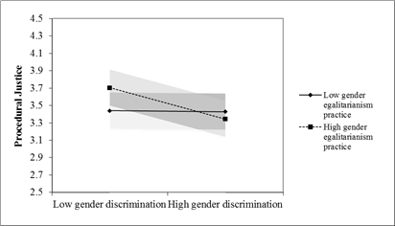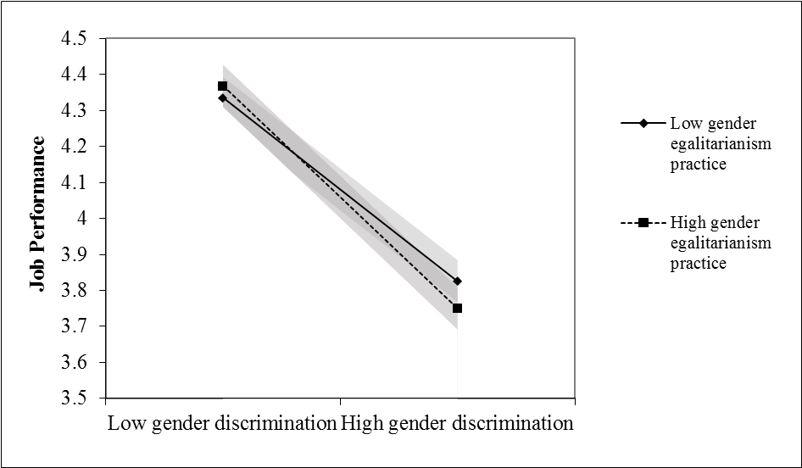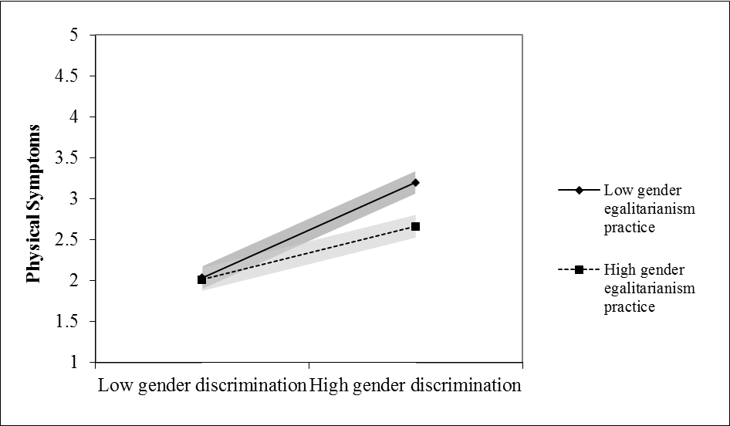

1 Shaded bands represent 95% confidence intervals.

Figure 2

Plots of Interactions for Labor Policy Integration and Practice Enforcement as Moderator1

(Complementary Study 1 – Employee Survey)

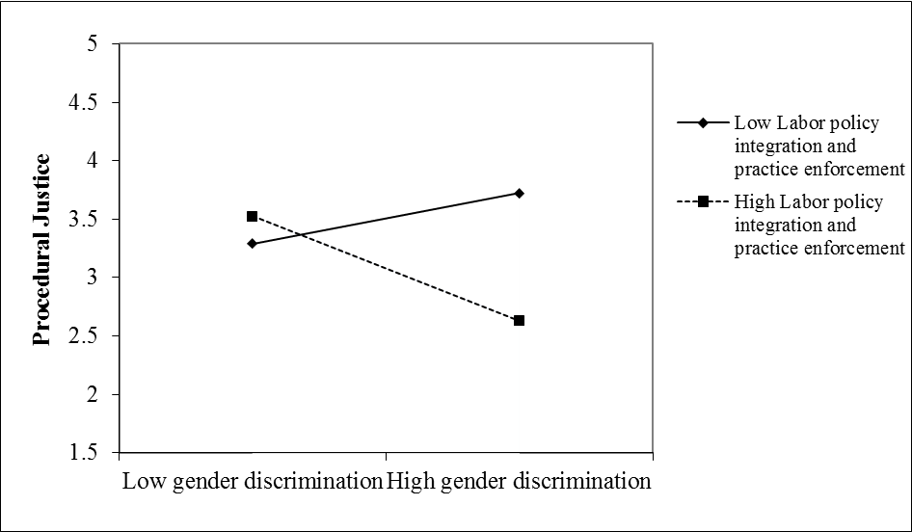 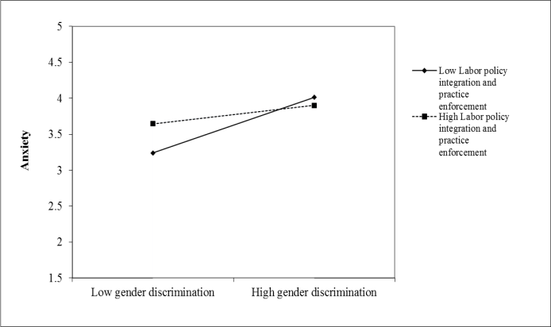

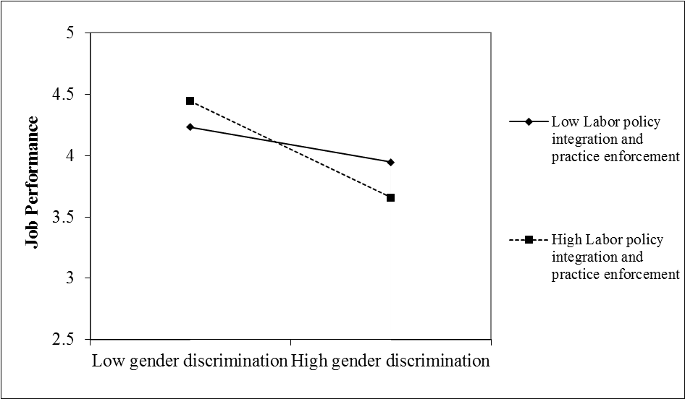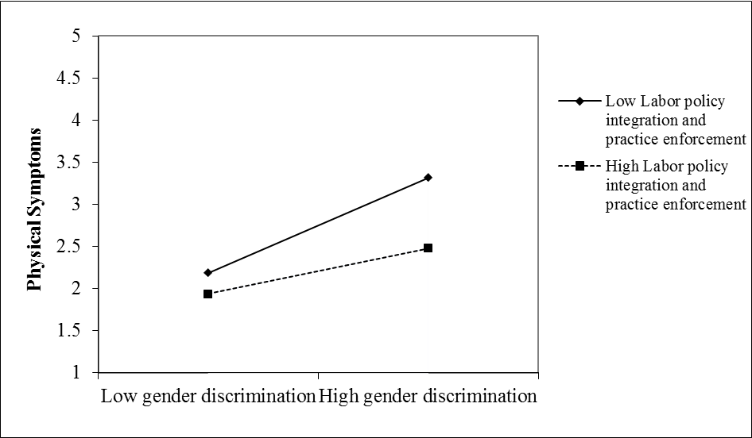

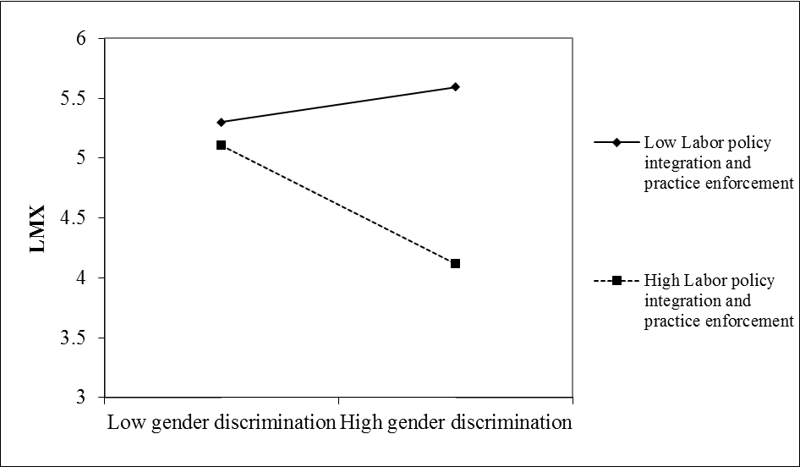

1 Shaded bands represent 95% confidence intervals. In some cases, smaller standard errors limit the visibility of the confidence bands.